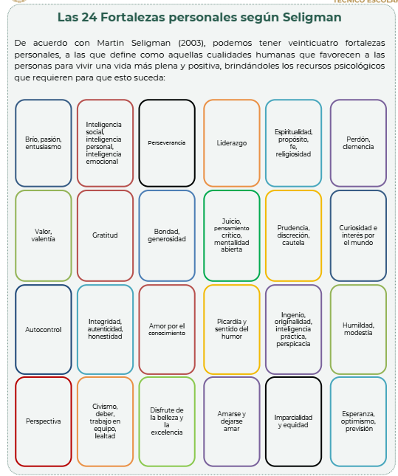

Por favor ser sincero y de manera respetuosa, realiza lo siguiente. Cualidades que mis amigos o compañeros detectan de mi:
______________________________________________________________________________________________________________________________________________________________________________________________________________________________________________________________________________________________________________________________________________________________________________________________________________________________________________________________________________________________________________________________________________________________________________________________________________________________________________________________________________________________________________________________________________________________________________________________________________________________________________________________________________________________________________________________________________________________________________________________________________________________________________________________________________________________________________________________________________________________________________________________________________________________________________________________________________________________________________________________________________________________________________________________________________________________________________________________________________________________________________________________________________________________________________________________________________

