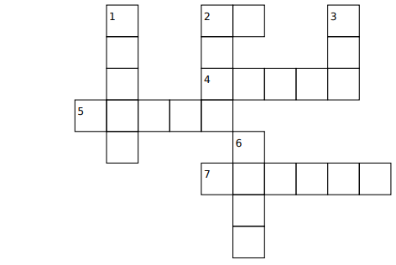

Down Across:
1. the windows 2. the homework
2. the furniture 4. the floor
3. the floor 5. the walls
6. the car 7. the house

