Subject pronouns
Match the proper subject pronouns with the nouns.
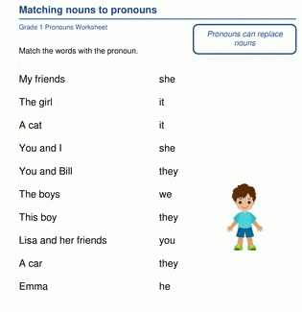

VERB TO BE
Complete the following activities with the correct form of the verb be.
