Homework
Using the following characteristics about personality make some predictions using the “going to” to talk about future.
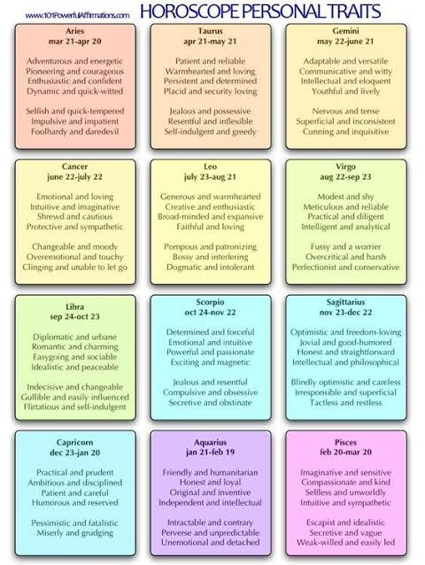

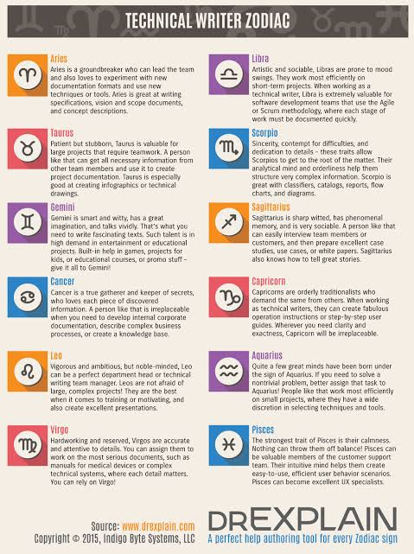

Homework: Write some predictions using the chinese horoscope, and compare with the zodiac one.

