Reported Request

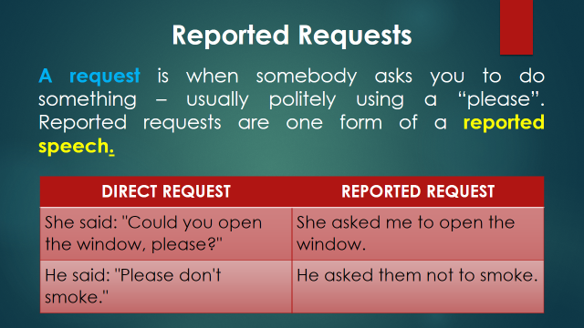

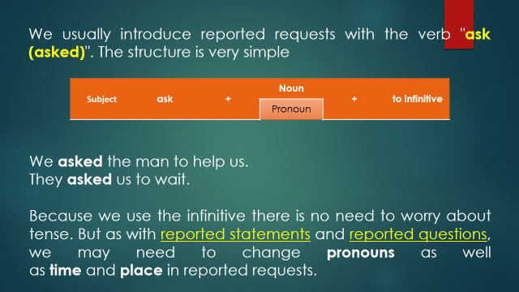

DIRECT REQUEST | REPORTED REQUEST
I said politely, "Please make less noise." | I asked them politely to make less noise.
She has often said to me, "Could you stay the night?" | She has often asked me to stay the night.
They said to the architect: "We'd like you to meet us here tomorrow." | They asked the architect to meet them there the next day.
She will certainly say to John, "Please stay for lunch." | She will certainly ask John to stay for lunch
She always says, "Please don't forget me." | She always asks me not to forget her.
Alejandra says: “Please help me carry this.” | She/Alejandra asked me to carry that.
Teacher says: “Please come early.” | The teacher asked us/me to come early

Answer the following exercises.
DIRECT REQUEST | REPORTED REQUEST
She says: “Please buy some milk”
Carlos says: “ Do your homework”
The teacher says: “Don´t be late.”
My mom says: “Go to bed.”
My mom says: “Do the washing-up.”
My boss says: “don’t forget my ID”.

