WANT + OBJECT PRONOUN + TO VERB

I
You
He
She
It
We
You
They

want / wants
___________
wanted
me
you
him
her
it
us
you
them

to + verb

INFINITIVE OF PURPOSE

Examples:
- Alejandra wants me to help around the house.
- They want him to buy a soda.
- My mom wanted me to turn on the TV.
- My friends want him to explain again the homework.
- The teacher wanted us to study fo the exam.

INFINITIVE OF PURPOSE
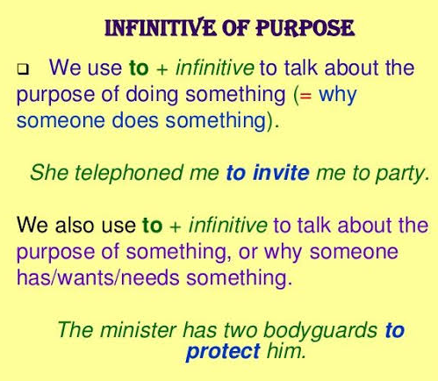

Homework: imprime y pega los ejercicios siguientes en tu libreta para practicar el tema de “infinitivos de propósito”.
