**Activity 1. Instructions: Read the following reading and answer the activities with the information.**

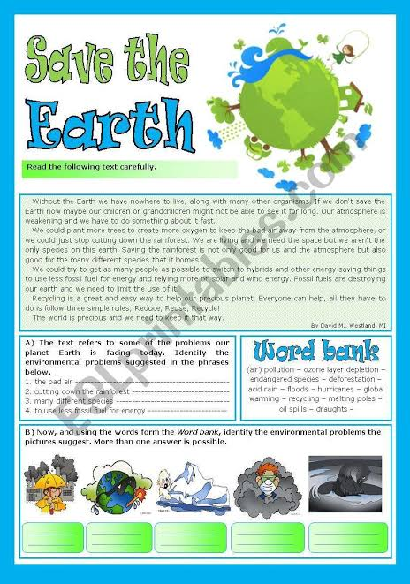

**Activity 2. Instructions: Read the following reading and answer the activities with the information.**

