READING
Read the following text about Siberia and answer the questions below about it.
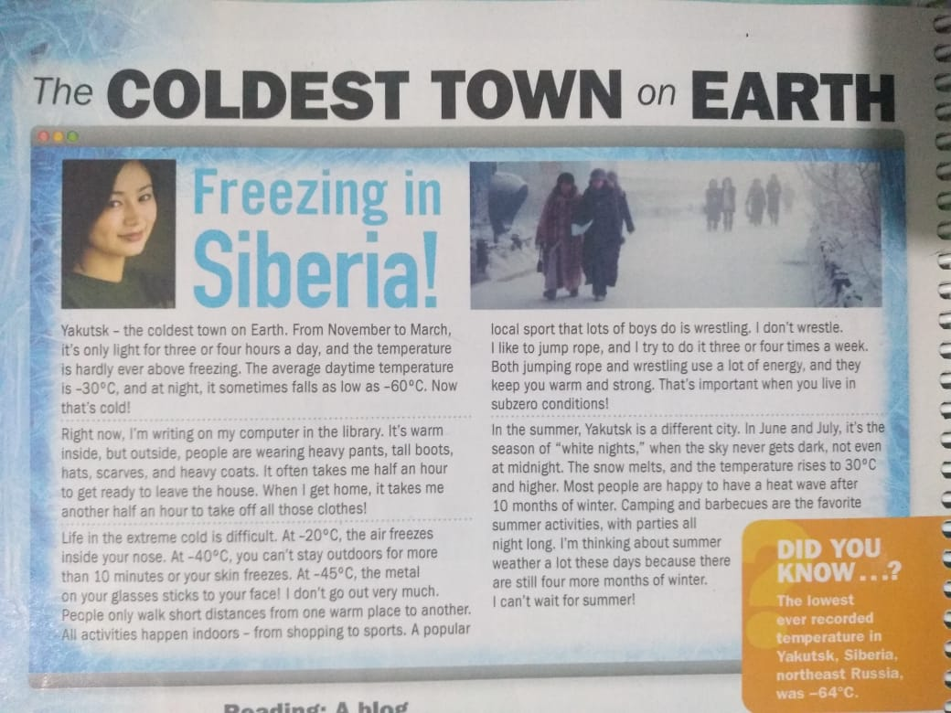

After reading the text answer the following questions on your notebook.
