NEWSPAPER ARTICLE
Look at the following newspaper article and identify the kind of information is given, and how is written.

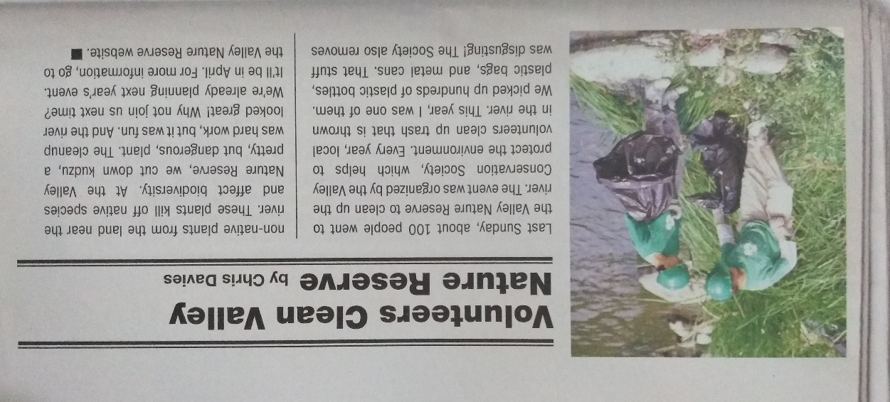

Focus on the following information that must be included in a newspaper article.
Using these informationyou will write a short newspaper article including those data about an event you consider important. You have to write it using passive voice as it was checked in class. The article will be written on the notebook and in a poster to be exposed in class next week.

