ADJECTIVES WITH PARTICIPLE (-ING & -ED)

- Depending of each situation, use the given verb using the –ing or the –ed ending that belongs.

Example:

- You see an accident. How do you feel? When I see an accident I feel shocked.

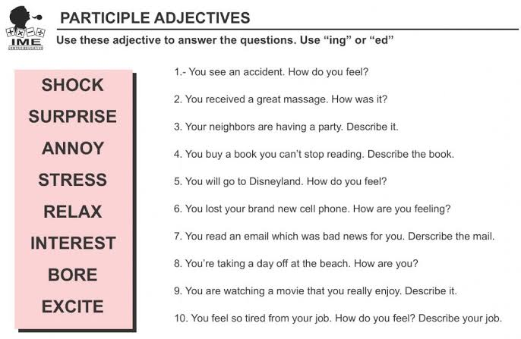

- Complete the sentences using the two options that complete better each one.

