**SIMPLE PAST**

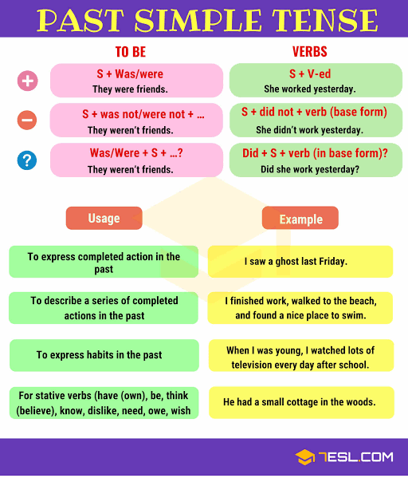

Were they Friends?

WAS – I, he, she & it

Wasn’t

-------

WERE – we, you & they

Weren’t

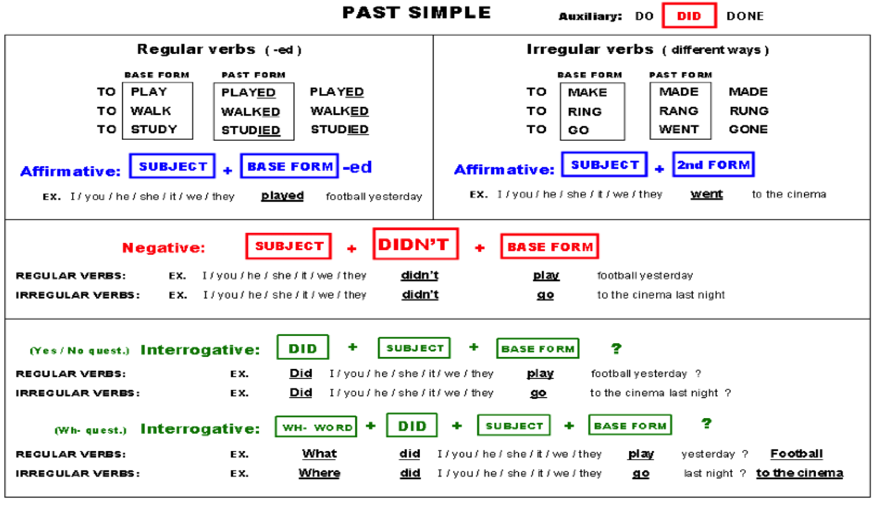

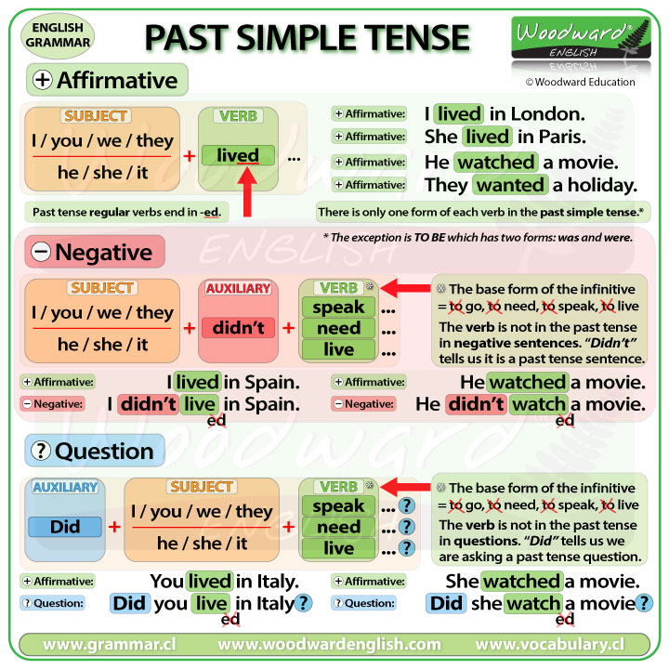

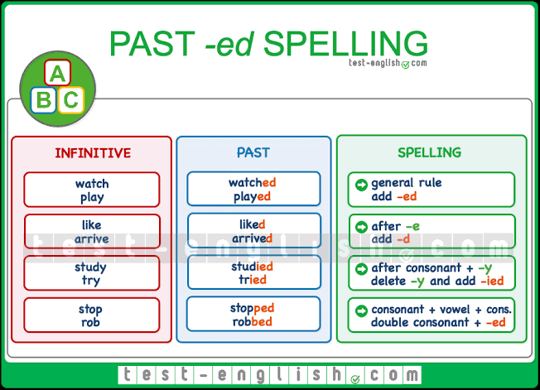

**Homework: Answer the following exercises.**

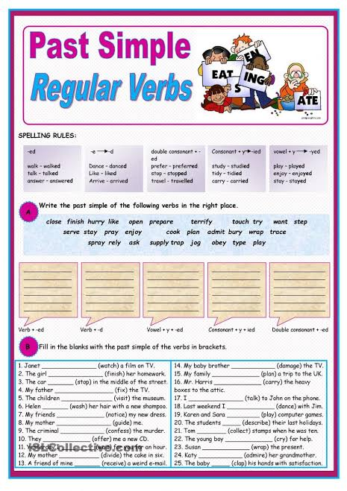

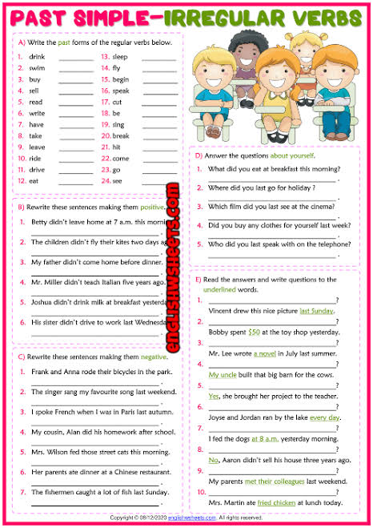

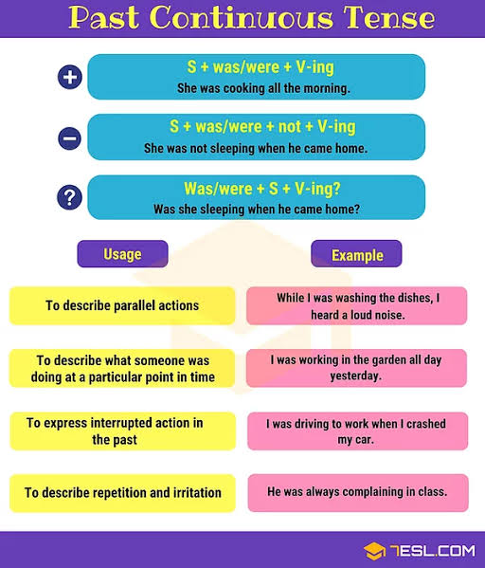

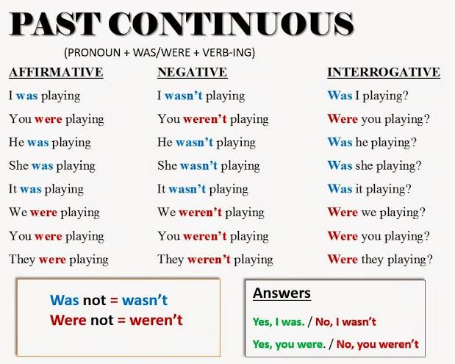

**Exercise: Answer the following exercises:**

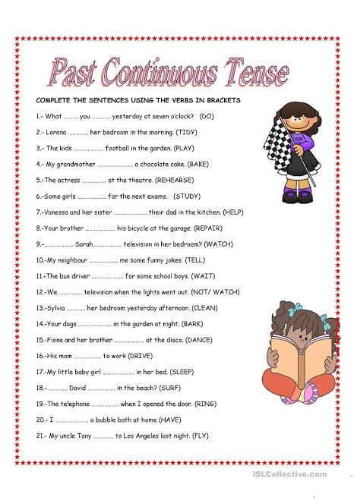

I was reading a book when my mother came in.

When my mother came in, I was reading a book

Why were not (weren´t) you watching the movie?

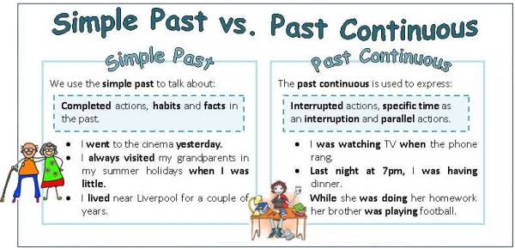

**Exercise: Answer the following exercises about how to use simple past and past continuous and the same time:**

