**PRESENT PERFECT WITH “ALREADY, YET & JUST”.**

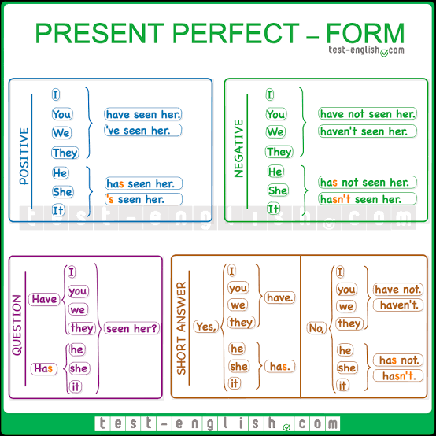 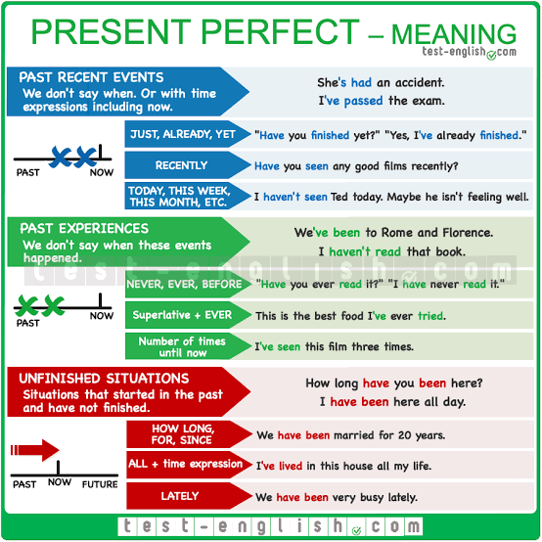

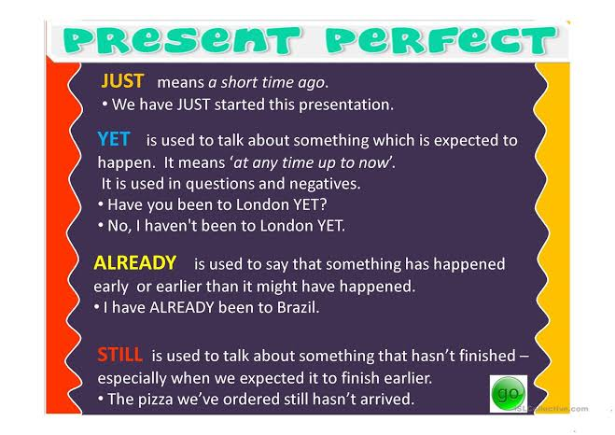

**Homework: Answer the following exercises:**

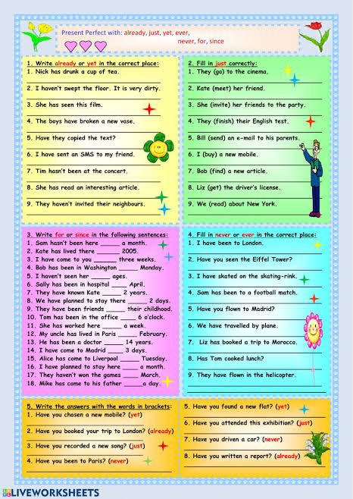

**Present perfect with “FOR & SINCE”.**

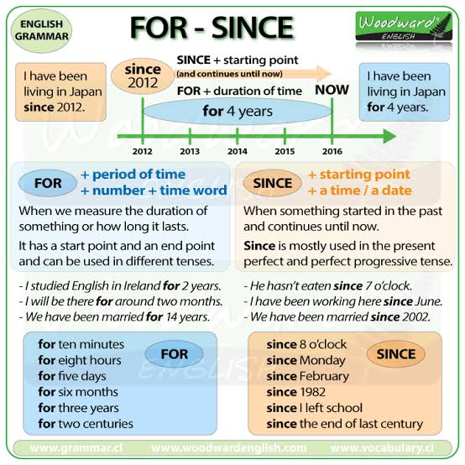

Homework: Answer the following exercises about present perfect using fot & since.

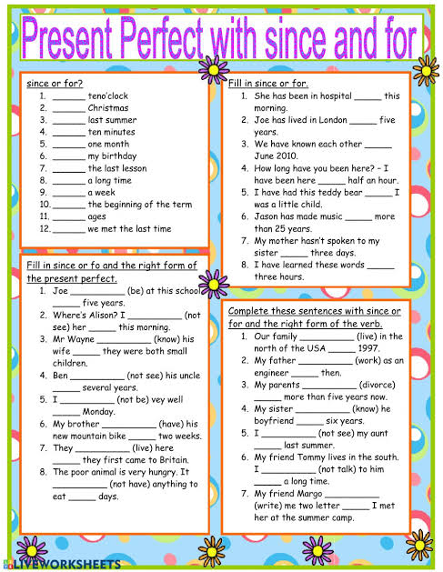

Summary:

