Activity: Complete the following exercises about 2nd conditional

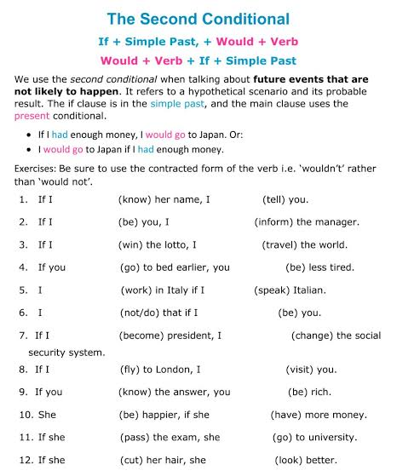

Activity: Complete the folowing sentences in 2nd conditional with your own ideas to complete them.

