PARTS OF THE HOUSE
- Answer the following activity about the house.

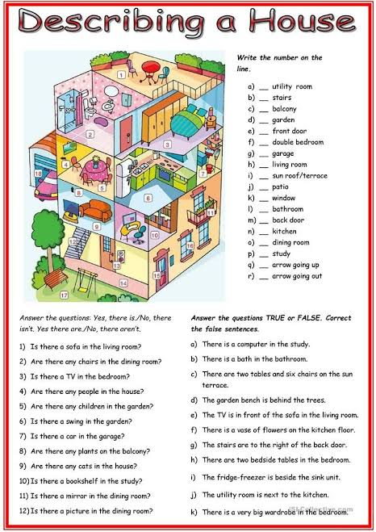

- The following activity about describing a house and complete the exercises.

