PREDICTING FUTURE CHANGES
Look at the following paragraph of opinion about a future prediction.
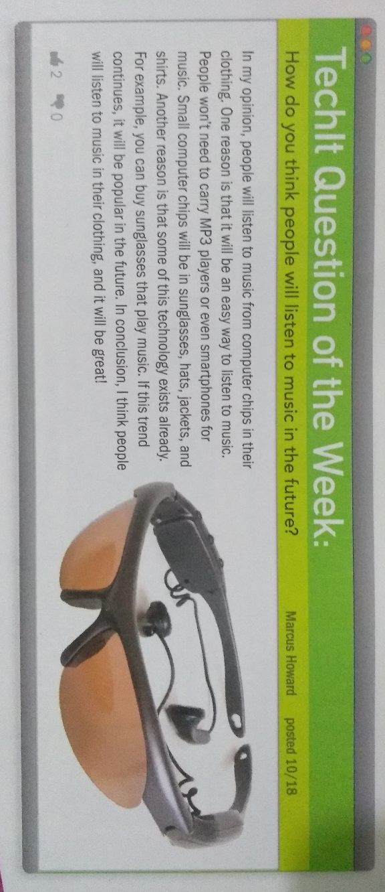

After having Reading the paragraph, you will choose one of the topics below in order to write your own paragraph giving your opinión about one of the topics with the introduction, reasons, examples, and a conclusión about it.

The topics will be written on the notebook, and on a poster to be exposed in class the next week.

