COUNTRIES
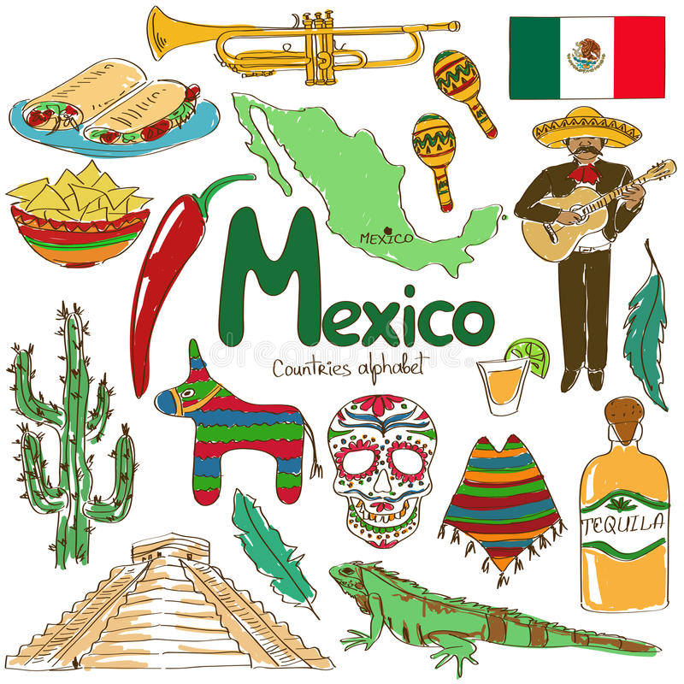

I will talk about Mexico.
Mexico is in North America. Its oficial language is spanish and it is next to the USA in the north, and Guatemala & Belize in the south.
The capital of Mexico is Mexico City, and it is one of the largest cities in the world.
Its flag is green, white, and red with an Eagle devouring a snake.
In Mexico there are a lot of typical dishes, some od the most famous are tacos, nachos, chili, mole, etc. The typical drink is the tequila.
The typical music is mariachi music, and the charro costume is the typical clothes.
In the celebrations is common to find piñatas that are made of cardboard and color paper filled with candies, and in the “Dia de muertos” celebration the sugar skulls are one of the most common elements in an offering.
In Mexico there are a lot of animals and plants that are native such as the iguanas and cactus.
Finally, there are many archeological areas in Mexico. The pyramid in the image is the pyramid of Chichen Itza in Yucatan.
* Homework
Elaborar una descripción similar al ejemplo de arriba utilizando el verbo BE y el THERE IS / THERE ARE para indicar que hay en cada país. Además investigar el nombre de edificios/monumentos, ropa, baile, comida típica de cada país.
La tarea será elaborarla en su libreta y se presentara de manera oral en clase a partir del día viernes 14 de octubre.
Todos deben estar preparados para pasar ya que si ese día no tienen elaborada la pequeña investigación, o argumentan no estar preparados para exponer, no se le dará oportunidad de hacerla en otro día ya que se les está dando tiempo suficiente para realizarla.
A continuación se enlistan los países que cada uno expondrá e investigará para la tarea.
- Ximena Balcazar Australia
- Jared Brazil
- Matias China
- Montserrat Denmark
- Irving Egypt
- Julio England
- Valeria Loranca France
- Maria Renee German
- Miguel Angel India
- Angel Jesus Ireland
- Daniela Urbina Italy
- Valeria Guadalupe Japan
- Johan Russia
- Ximena Rustrian Kenya

