**VERB HAVE**

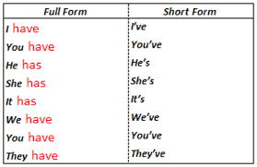

**THE FAMILY MEMBERS**

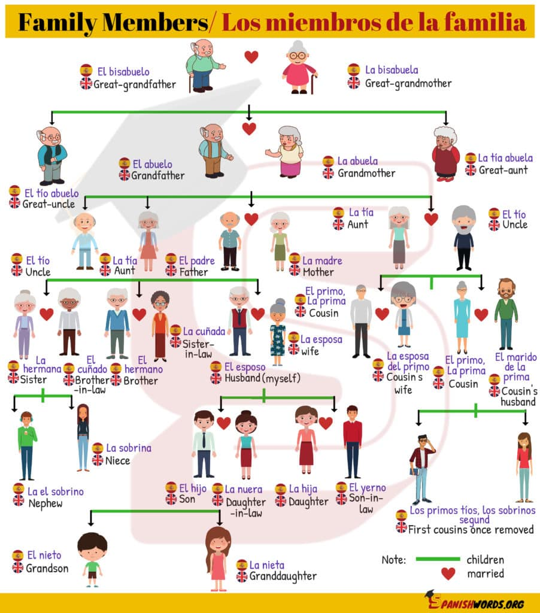

**Complete the sentenses with the rigth family member.**

