COUNTABLE & UNCOUNTABLE NOUNS
- Do the following exercises about countable and uncountable nouns.

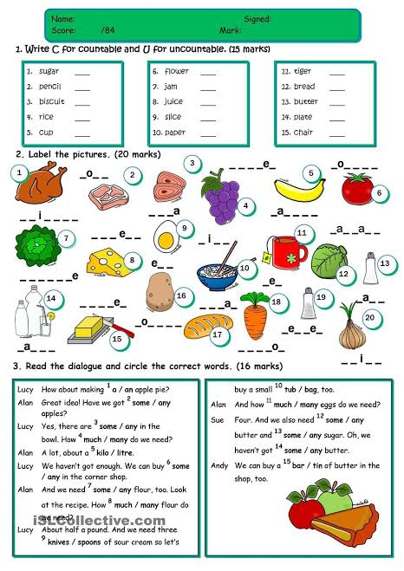

- Complete de following sentences with the words that are given in the instructions.

