VERB “CAN” FOR ABILITY
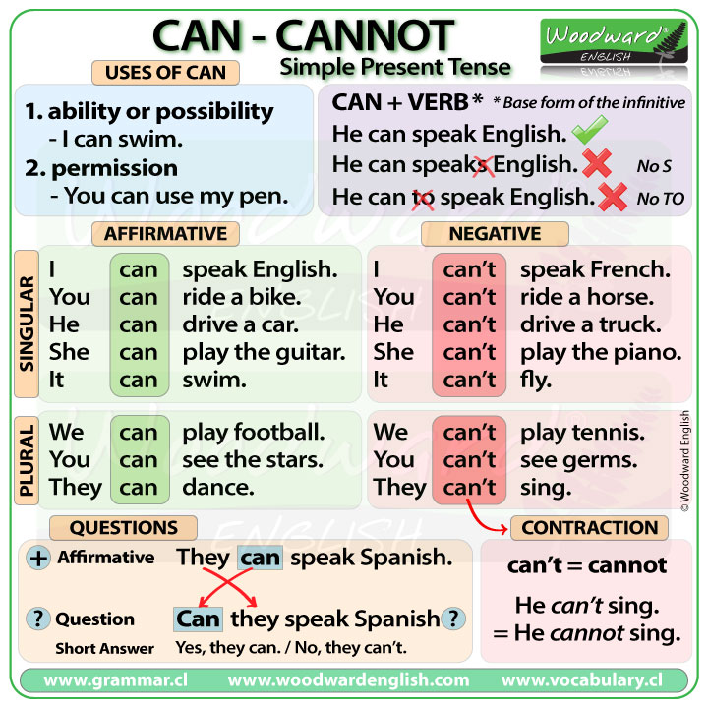

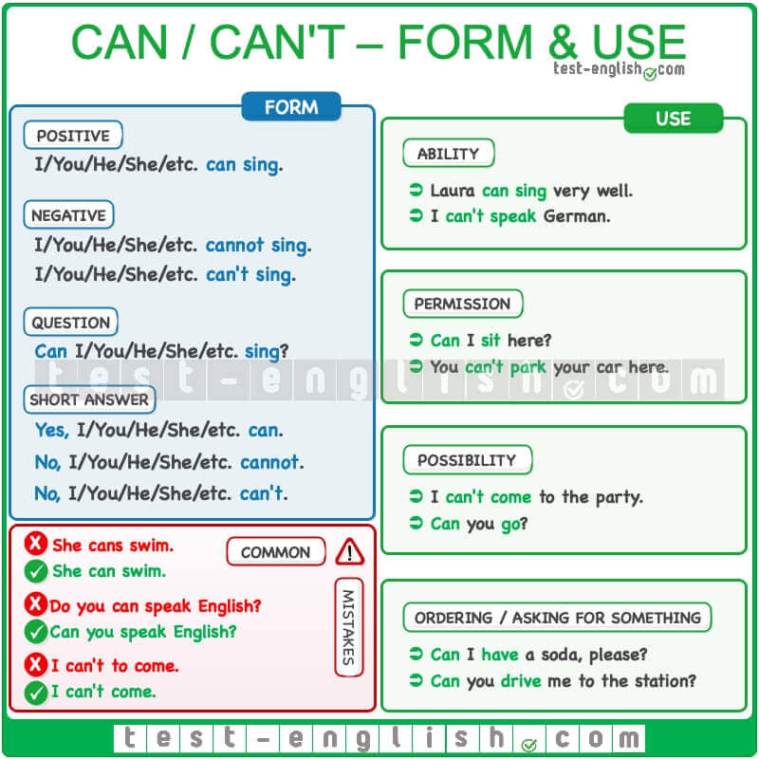
Activity: Do the following exercises about verb CAN, print and paste i ton your notebook.
